COMPUTER SCIENCE FUNDAMENTALS & CARRIER PATHWAYS
Assignment : 2
NAME : ARUN SINGH
ROLL NO. : 2501630010
PROGRAMME: B.TECH CSE (ROBOTICS AND AI)
COURSE NAME : COMPUTER SCIENCE
COURSE CODE : ETCCCP105
SUBMITTED TO: RAVINDER BENIWAL
Assignment Number 02:Basics of Linux and Open-Source Tools

Assignment Title: How Can You Demonstrate Linux Setup, Command Usage, and Automation Through Practical Implementation?
WSL (Windows Subsystem for Linux) Installation Steps
WSL (Windows Subsystem for Linux) Installation Steps
Hardware Configuration Example
- Processor: Intel Core i5, 4 cores
- RAM: 8 GB
- Disk Space Allocated: 10-20 GB (will depend on your settings)
- Operating System: Windows 10/11
- Step 1. Enabling WSL Feature
- Opening Windows Search, type “Turn Windows features on or off”.
- Scroll and tick “Windows Subsystem for Linux”.
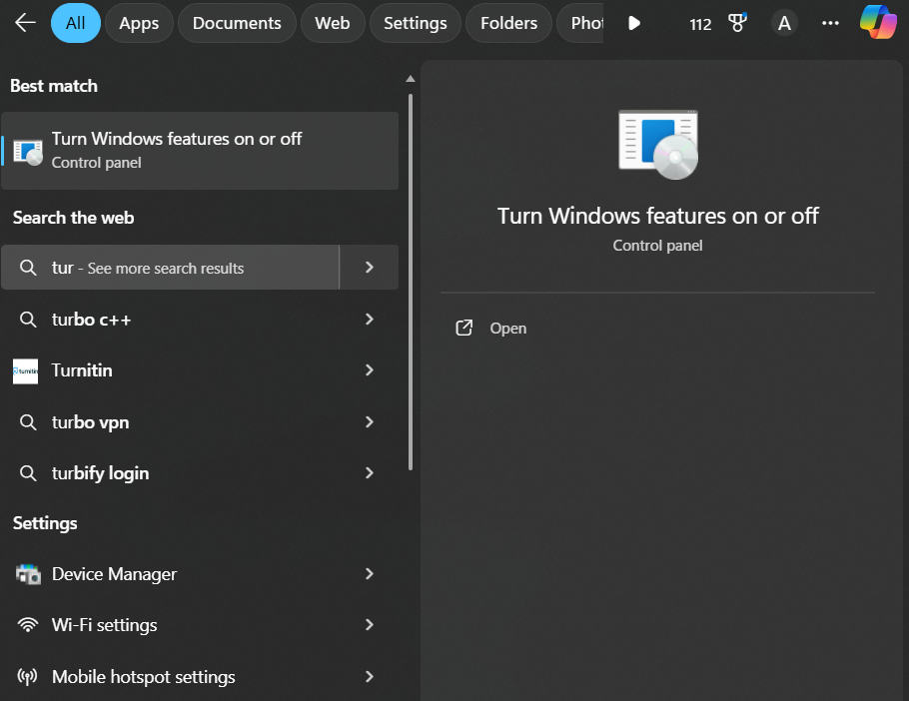
- Scroll and tick “Windows Subsystem for Linux”.
- Also, optionally tick “Virtual Machine Platform” for WSL2.
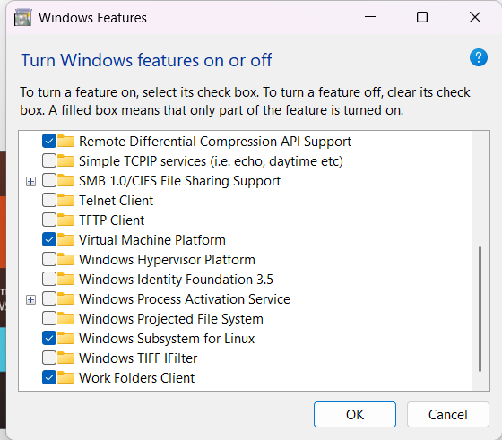
2. Restart Your Computer
- Windows will prompt for a restart.
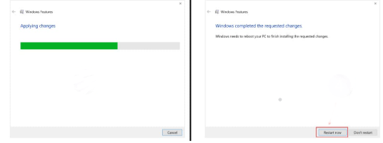

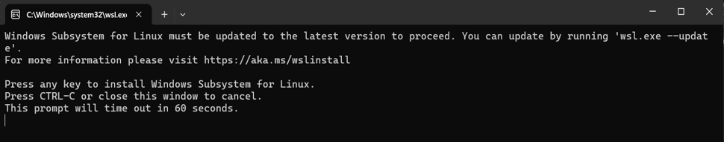
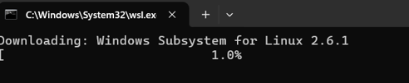
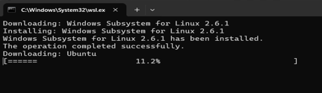
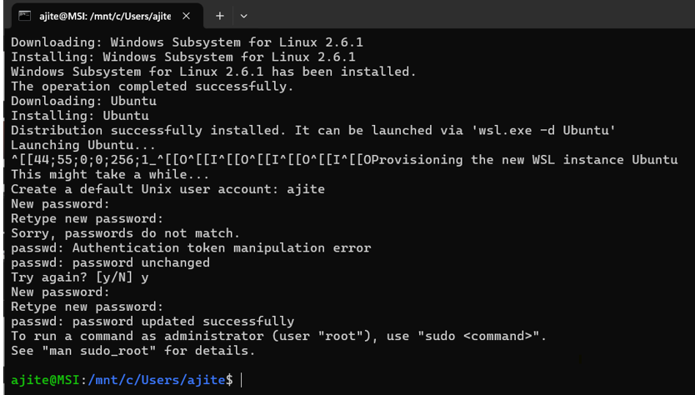

a) File Navigation system
i)pwd: Print current working directory.(home/ajite)
Attribute | Detail | When & Why Used
Syntax | pwd | Used when scripting or troubleshooting to confirm exactly where you are in the file system.
Description | Prints the full absolute path of the current working directory. | Confirmed the current location was /home/ajite and /home/ajite/scripts during file creation.

ii)To Access The Files Of My windows in WSL system
cd: it is used to change directory. It's used to navigate between folders.
Attribute | Detail | When & Why Used
Syntax | cd [DIRECTORY] | Used constantly to navigate the file system. cd ~ returns to the home directory.
Description | Changes the shell's current working directory. | Used to move into the new directory comp_fund_assignment after creation.

/ cd
Cd mnt/c
It tells the shell to start from the root of the Ubuntu file system (/). The correct path to our Windows C: drive .
The ls command in Linux is used to list the contents of directories
Attribute | Detail | When & Why Used
Syntax | ls [OPTIONS] [FILE...] | Used routinely to see what's in a folder and confirm file creation. Options like -l show detailed permissions.
Description | Lists the contents (files and directories) of the current or specified directory. | Used to verify files in comp_fund_assignment.

iii) ls – ls[file/foders]
ls -l – Detailed view ls -l [FILE/DIR]
ls -a – Show hidden files ls -a [FILE/DIR]
Tree: tree [OPTIONS] [DIRECTORY]
Installing tree command using
1)sudo apt update
2) sudo apt install tree
Attribute | Detail | When & Why Used
Syntax | tree [OPTIONS] [DIRECTORY] | Used for documentation or visualization to show the hierarchical structure of a project.
Description | Displays the contents of a directory in a tree-like format. | Used to visualize the successful creation of all script folders (backups, downloads, monitor_logs, scripts).

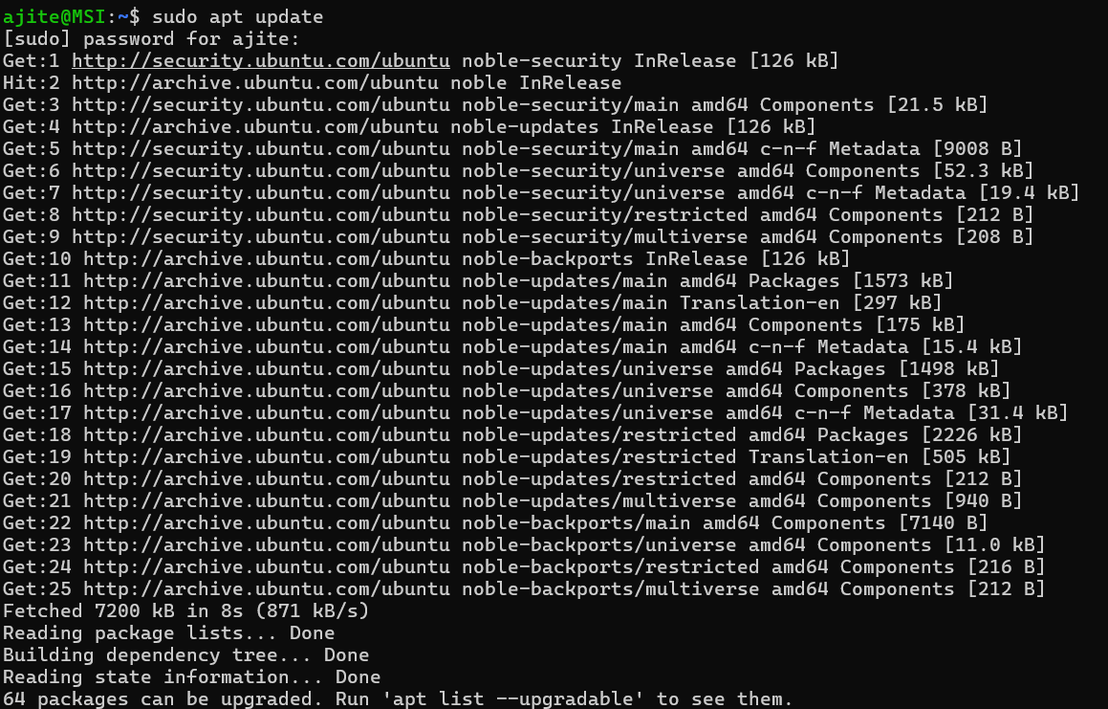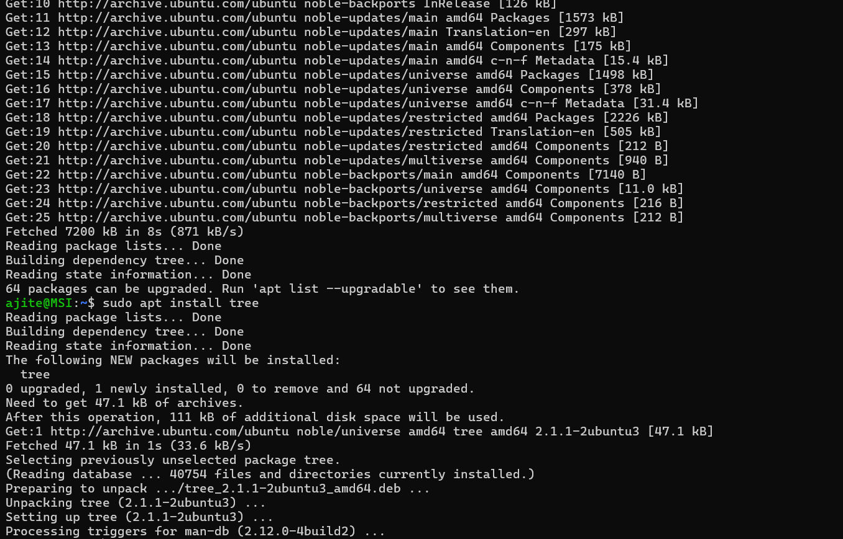

b)File and Directory Management:

i)Mkdir: mkdir commands are essential for organizing our files and directories in Linux. It allows us to create new directories.
Attribute | Detail | When & Why Used
Syntax | mkdir [OPTIONS] DIRECTORY... | Used to organize files and set up project structures. The -p option creates parent directories as needed.
Description | Makes a new directory. | Used to create comp_fund_assignment.

Step1) • cd~ Is a shortcut for the current user's home directory. This command changes the current location to the user's home directory.
Step2)mkdir comp_fund_assignment: Is the name of the new directory being created.
ii)touch:The touch command in Linux and other Unix-like operating systems is primarily used to create a new, empty file.
Attribute | Detail | When & Why Used
Syntax | touch [OPTIONS] FILE... | Used to quickly create placeholders or temporary files without needing an editor.
Description | Creates a new empty file or updates the access/modification timestamps of an existing file. | Used in the background of your assignment to create files like new.txt.

step1)I created new file new.txt using touch new.txt.
step2) The ls (list) command is executed to see what files and directories are present in the current location (comp_fund_assignment).

iii)cp: The cp command in Linux is used to copy files and directories from one location to another.To copy an entire directory along with all its contents (subdirectories and files), you must use the -r (recursive) option. Without -r, cp will not copy directories.
Attribute | Detail | When & Why Used
Syntax | cp [OPTIONS] SOURCE DEST | Used to create duplicates of data or configuration files. The -r option is essential for copying directories.
Description | Copies files and directories. | Used within your backup.sh script to copy the source directory.

Step1)I first created a new file in my home/pratyush/ directory . 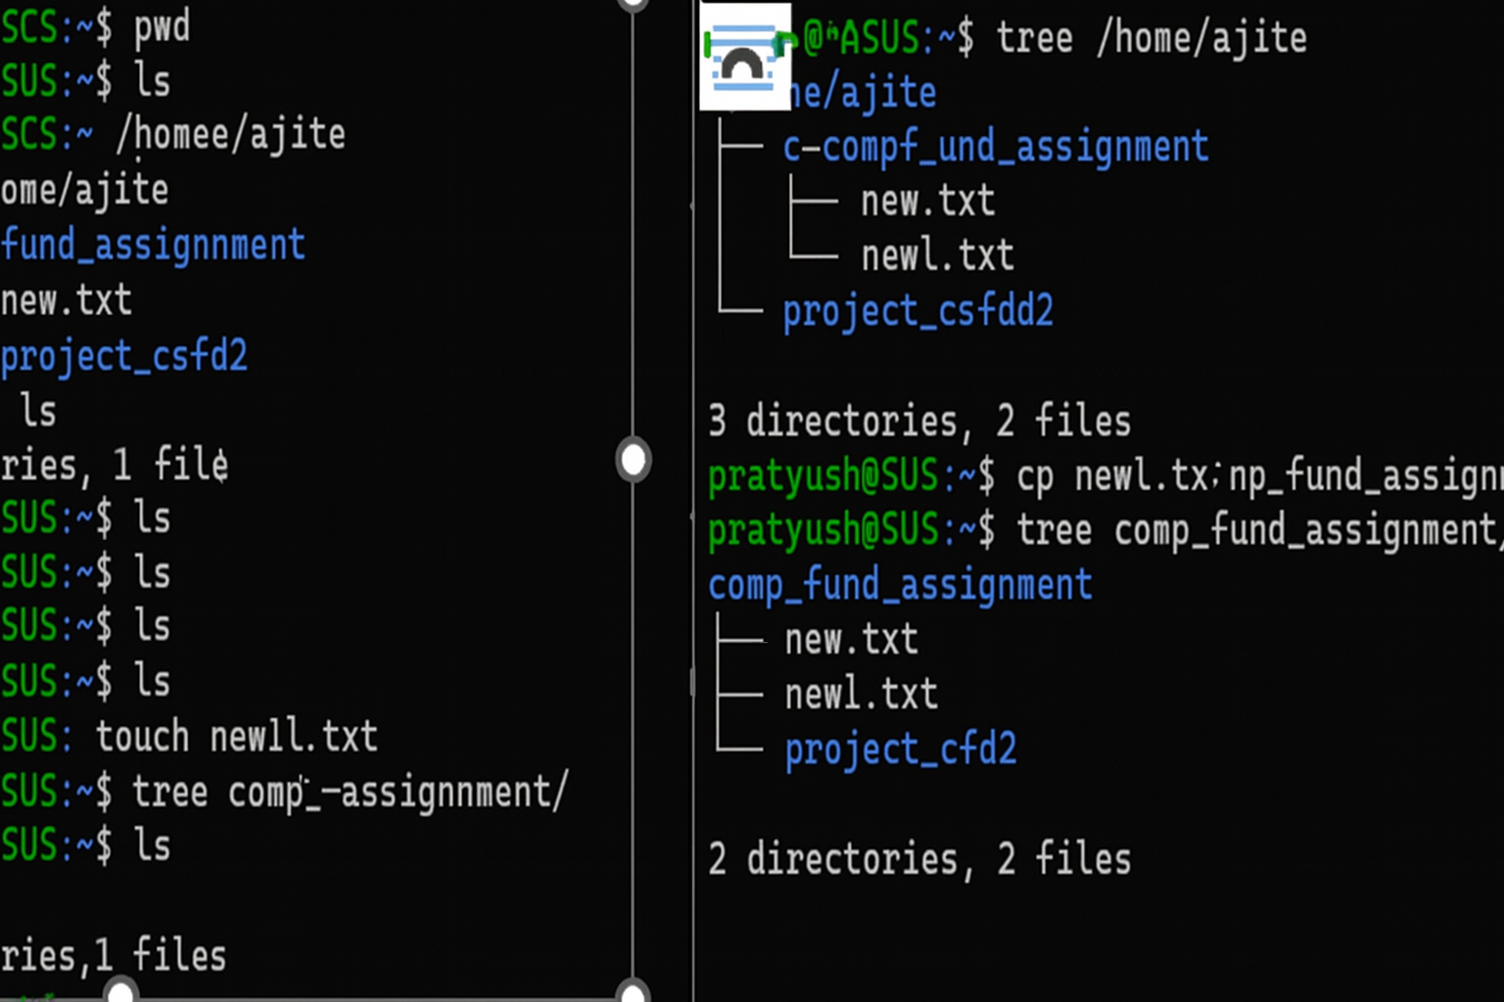
Step2) I then copied it in my comp-fund_assignment using cp new1.txt comp_fund_assignment/.
iv)mv:The mv command in Linux is used for two primary file operations: moving files and directories and renaming files and directories.
Attribute | Detail | When & Why Used
Syntax | mv [OPTIONS] SOURCE DEST | Used to rename files or move them to a new location.
Description | Moves (renames) files or directories. | Used to reorganize files by moving them into different directories.

v)rm: The rm command is essential for managing files and directories in Linux. They allow us to remove existing items .
Attribute | Detail | When & Why Used
Syntax | rm [OPTIONS] FILE... | Used to delete files. The -r (recursive) and -f (force) options are used with caution for deleting directories.
Description | Removes (deletes) files and directories. | Used to clean up temporary or unnecessary files and directories.

step1)I used (pwd) to check that I am in my home directory.
Step2)I used (cd comp_fund-assignment ) to change the current directory to comp_fund_assignment .
Step3)then I used (rm new.txt) to delete this file and at last use ls to verify it is deleted.

c)Permissions Management: i)chmod:The chmod command is used to modify file and directory permissions .
Attribute | Detail | When & Why Used
Syntax | chmod [OPTIONS] MODE FILE... | Used before running scripts to give execution permission (+x), or to restrict file access for security.
Description | Change file mode. Modifies the access permissions (read, write, execute) of a file or directory. | Used to make your shell scripts executable (chmod +x *.sh).

There are two modes:1.symbolic 2.octal
a)octal:step1)Applying (ls -new1.txt) to check the current permissions then used (chmod 640 new1.txt) to change the permisions . chmod XXX FILE(s)
b) symbolic (chmod u=rw,g=r,o= new.txt)
u=rw:Explicitly sets the owner's permissions to Read and Write
g=r: Explicitly sets the group's permissions to Read only
o=: Explicitly sets the others' permissions to nothing
will do the same thing. chmod [WHO][OP][PERM] FILE(s)

ii)chown: The chown (change owner) command is used in Linux to change the user and/or group ownership of a file or directory.
Attribute | Detail | When & Why Used
Syntax | chown [OPTIONS] USER[:GROUP] FILE... | Used when managing web servers or shared environments to ensure services or different users have correct access. It often requires sudo.
Description | Change file owner. Changes the user and/or group ownership of a file or directory. | Used to transfer file ownership from one user/group to another.

step1) Creating a group and creating a User and running sudo chown webmin:developers config.ini and we used colon (:) to specify the new user and new group.
d)Process Monitoring:
i)Ps: The basic ps command shows only processes owned by your current user in the current terminal session. To get useful information, you usually combine it with options.
Attribute | Detail | When & Why Used
Syntax | ps [OPTIONS] | Used to identify the PID (Process ID) of a process, especially when looking for background jobs or processes consuming too many resources.
Description | Process status. Reports a snapshot of the current running processes. | Used to find the PID of the sleep 60 background job.

ii)top: it’s an essential command for process management! The top command provides a dynamic, real-time look at your system's activity.
Attribute | Detail | When & Why Used
Syntax | top | Used for immediate monitoring to diagnose a slow or unresponsive system and identify the biggest resource hogs.
Description | Provides a real-time, interactive view of system processes, displaying CPU and memory usage dynamically. | Used in the background of your monitor.sh script to collect system usage data.

iii)kill: This command is used to terminate processes by sending signals to them:
Attribute | Detail | When & Why Used
Syntax | kill [OPTIONS] PID... | Used to stop unresponsive programs. The -9 option is used to forcefully terminate stubborn processes.
Description | Sends a signal to a process to terminate or modify its behavior. | Used to terminate the background sleep 60 process after identifying its PID.
other users or the system.
Steps done in this code:
sleep 60 runs for 60 seconds. The & puts it in the background. The system reports its job number ([1]) and its PID (859). Verify process is running.
Apply kill (sends SIGTERM)kill 859
The message [1]+ Terminated sleep 60 confirms that the process (Job 1) was successfully stopped by the kill command.
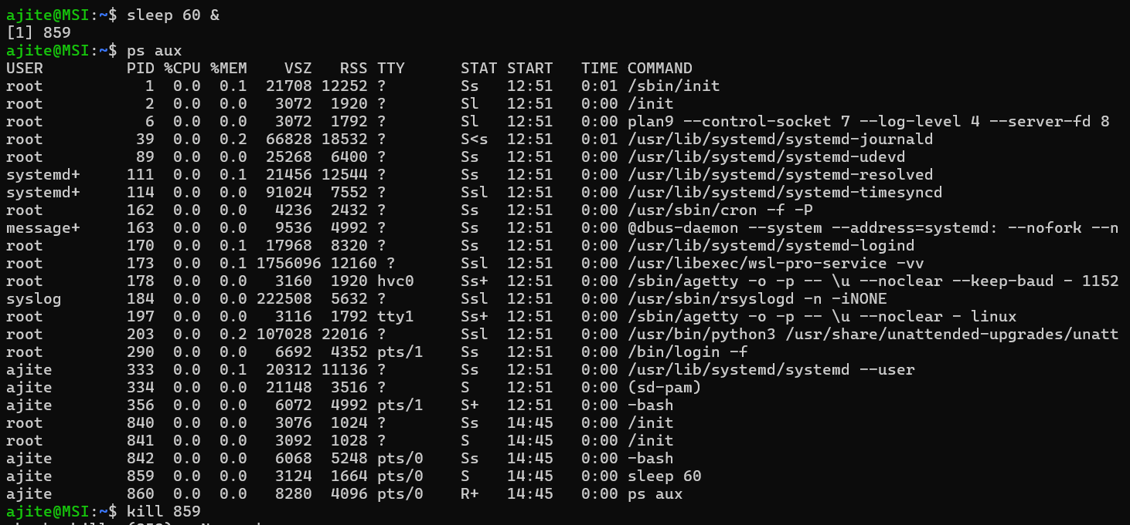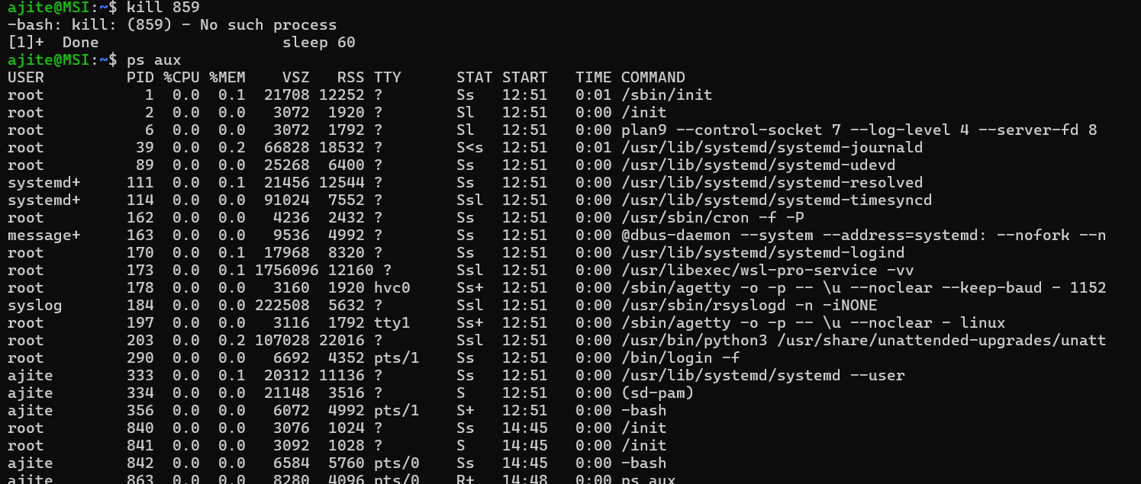
e)Networking Tools-The network commands ping, wget, and curl are fundamental tools used for network diagnostics, data retrieval, and web interaction.

i) ping:it is used to Check network connectivity.It uses ICMP (Internet Control Message Protocol)
Attribute | Detail | When & Why Used
Syntax | ping [OPTIONS] HOST | Used first in any network troubleshooting to check if a remote host is reachable and how fast the connection is.
Description | Sends ICMP echo requests to a network host to test connectivity and measure latency. | Used to test connectivity to 8.8.8.8 (Google DNS) and measure round-trip time (latency).

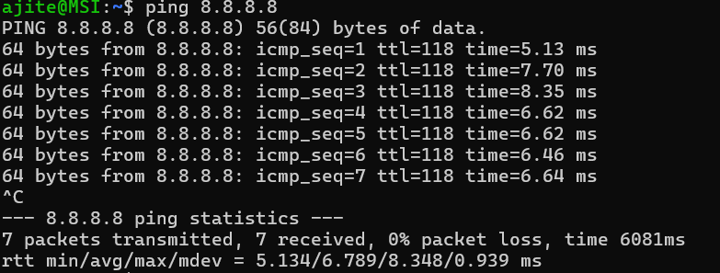
Steps:Pinging Google's public DNS server (a reliable target). It will run continuously to end it type ctrl+C.
Output Explained
The output tells you two main things: success and speed.
Metric | Explanation
64 bytes from 8.8.8.8 | Confirms that the target successfully received your packet and sent a reply.
icmp_seq=N | The sequence number of the packet (increments with each transmission).
time=8.68 ms | The latency or Round Trip Time (RTT). This is how fast the communication is. Lower numbers are better.
ttl=118 | Time To Live. A value that decreases each time the packet passes through a router.
0% packet loss | Crucial metric. Indicates that 0% of the sent packets failed to return. Any number above 0% means you have a connectivity issue.

Options available:
c -count → Limit number of pin
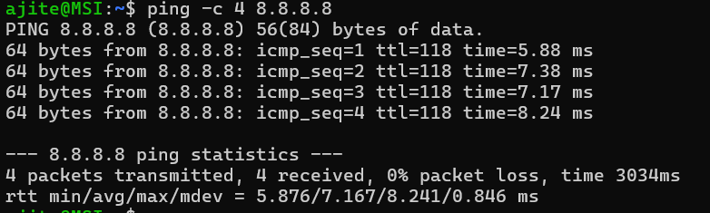
The command will automatically stop after sending and receiving the 5th packet.
i -interval → Set interval between pings

t -Windows or -w <sec> (Linux) → Timeout
The -w (wait) option defines a total time limit, in seconds, for the entire ping process to run, regardless of the number of packets sent. If the time expires, ping exits.

ping will stop running after 5 seconds, even if it hasn't sent many packets.

ii)ip/ifconfig : The ifconfig command (Interface Configuration) is considered deprecated but is still widely used and available on many systems, including WSL.
Attribute | Detail | When & Why Used
Syntax | ip a (modern) or ifconfig (legacy) | Used as the standard to get local network details (e.g., IP address, MAC address) and manage routing tables.
Description | Displays and manipulates routing, network devices, and interfaces (ip is modern; ifconfig is legacy). | Used to verify the IP configuration of your WSL system's network interfaces.

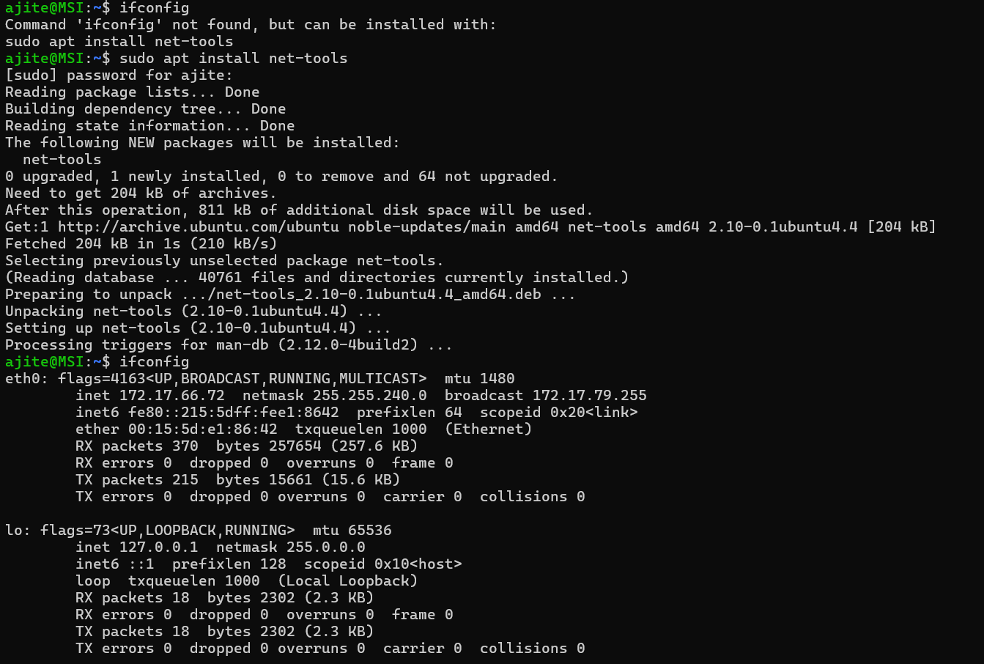
Displays details for all interfaces, similar to ip a.

ii)ip: The ip command is powerful and consolidates the functionality of many older tools (like ifconfig, route, and arp). It's the standard for configuring networking in modern Linux.
Syntax: ip [OPTION] OBJECT COMMAND
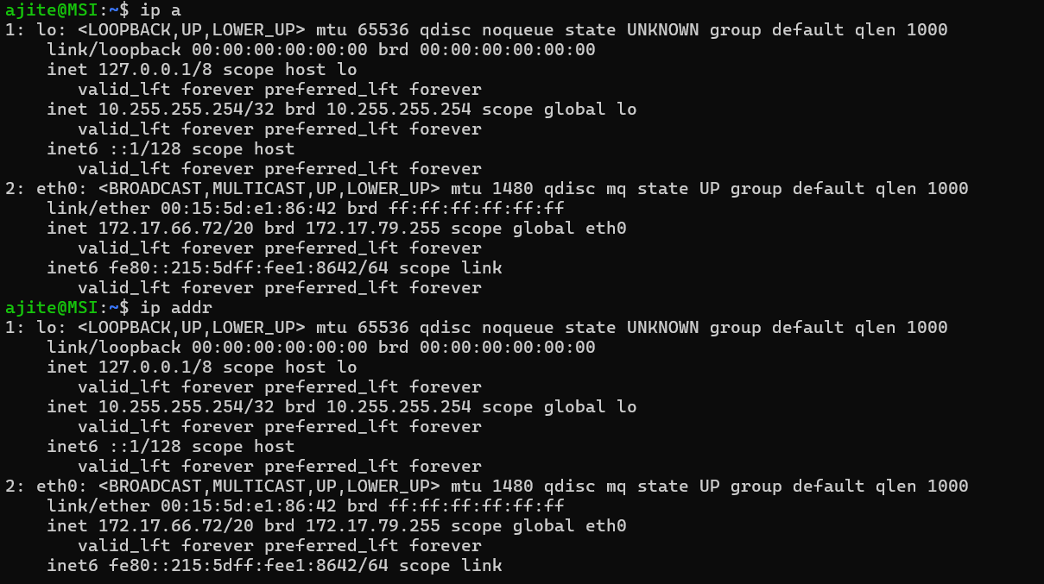
Displays details for all interfaces, including MAC addresses, IP addresses, and state.
iv)netstat: The netstat (network statistics) command is a legacy tool used to display active network connections, routing tables, interface statistics, and multicast membership. While ss (socket statistics) has replaced it in modern systems, netstat is still common.
Attribute | Detail
Syntax | netstat [ OPTIONS ]
Common Use | netstat -tuln
Description | Prints network connections, routing tables, interface statistics, masquerade connections, and multicast memberships. The options (-t, -u, -l, -n) are often combined to get specific views.

Step-by-Step Shell Script Development
Step 1: Create a Script Directory
First, let's create a dedicated folder for your scripts and move into it.
Command | Purpose
mkdir scripts | Creates a new directory named scripts.
cd scripts | Changes the directory to scripts.
pwd | Verifies your new location (/home/ajite/scripts).

Shell script development
Step-by-Step Shell Script Development
Step 1: Create a Script Directory
First,I created a dedicated folder for my scripts and move into it.
Script A: Backup a Directory (backup.sh)
This script copies a user-specified source directory to a backup destination, adding a timestamp to the backup folder name.
Action | Command (You would type)
Open editor | nano backup.sh

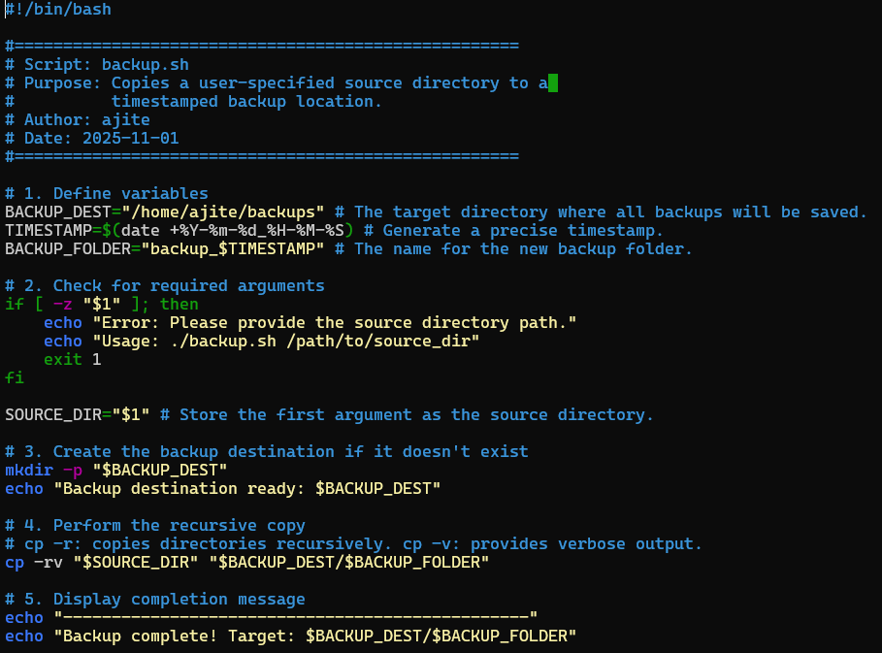
Step 3: Write Script B: CPU/Memory Monitoring (monitor.sh)
Action | Command (You would type)
Open editor | nano monitor.sh

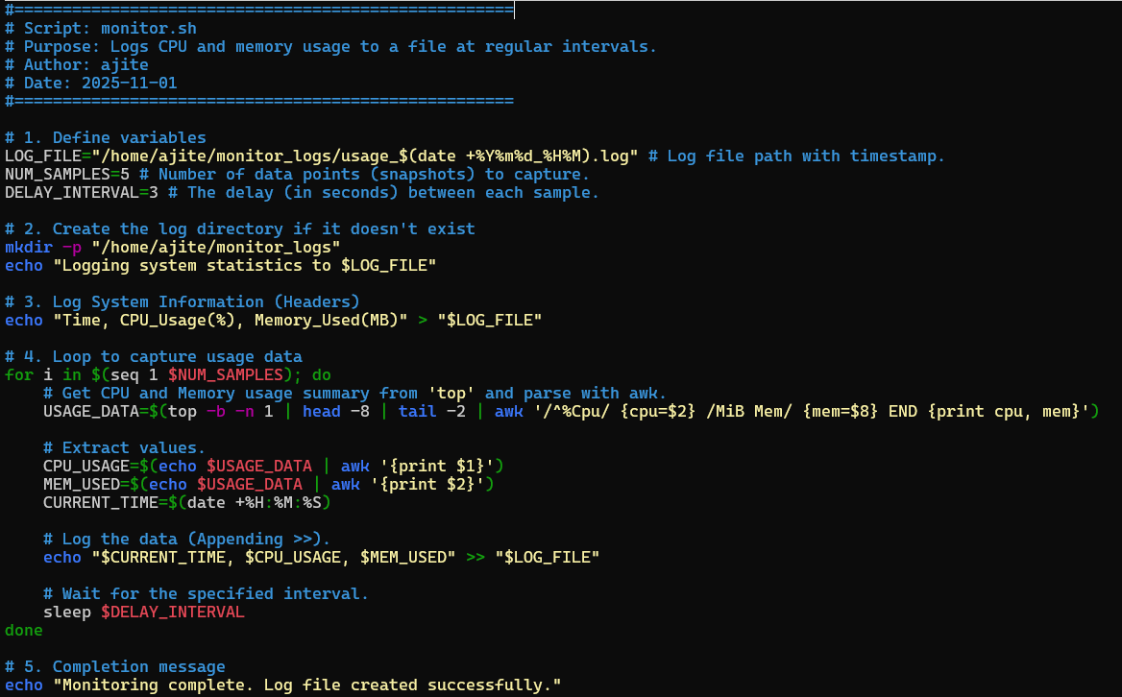
Script C: Automated Download Task (download.sh)
This script downloads a file from a specified URL using wget (a standard Linux download utility) and saves it to a predefined directory.
1. Create and Open the Script

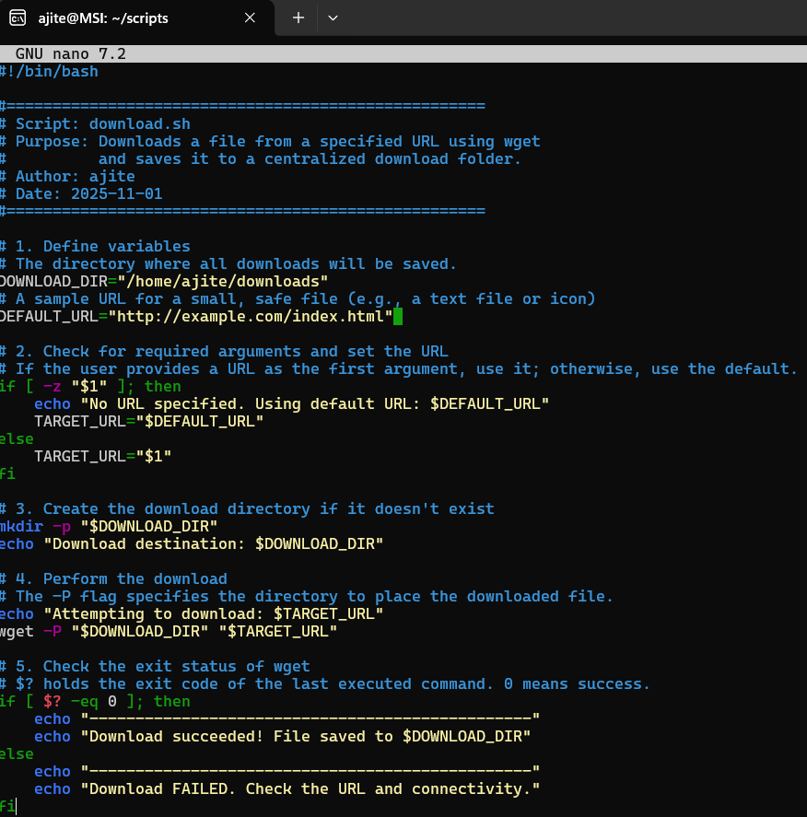
Step 5: Make Scripts Executable and Test
Before running any script, we must grant it execution permission using chmod. Test Backup Script (backup.sh)
This test confirms that the script correctly takes an argument and creates a timestamped backup folder in ~/backups.

Action | Command (You would type) | Test Run Example
Make all scripts executable | chmod +x *.sh
Test Backup Script | mkdir project_files  ./backup.sh project_files | Creates a project_files directory and backs it up to ~/backups/.
Test Monitoring Script | ./monitor.sh | Runs the script, logging data to ~/monitor_logs/.
Test Download Script | ./download.sh | Downloads the default robots.txt file to ~/downloads/.
Test 2: CPU/Memory Monitoring (monitor.sh)
Once the backup is verified, run the monitoring script. It will run for a short time (about 15 seconds) to collect data.
Command | Purpose
./monitor.sh | Executes the script, which collects system data and writes it to a log file in ~/monitor_logs/.
ls ~/monitor_logs | Checks the monitoring directory to find the newly created log file.
cat ~/monitor_logs/*.log | Displays the contents of the log file, showing the collected time, CPU, and memory data.
Test 3: Automated Download (download.sh)
Finally, test the download script.
Command | Purpose
./download.sh | Executes the script, downloading the default file (Google's robots.txt) and storing it in ~/downloads/.
ls ~/downloads | Verifies the download folder to confirm the file was saved correctly.

Step5: . Initialize Git Locally (WSL Terminal)
You will create a folder that matches your GitHub repository name and initialize it with the Git tools.
Step | Command (You would type) | Purpose
A. Creating Repo Folder | mkdir linux-shell-assignment | Creates the main folder for your submission.
B. Navigate | cd linux-shell-assignment | Enters the new folder.
C. Initialize Git | git init | Turns the current directory into a local Git repository.
D. Copy Scripts | cp -r ../shell_scripts . | Copies your completed shell_scripts folder into the new repository folder (assuming shell_scripts is in your home directory ~).
E. Stage Files | git add . | Stages (selects) all files and folders in the current directory for tracking.
F. Commit Files | git commit -m "Initial commit of three shell scripts" | Saves the staged files to your local repository history.

Report Section: Reflection
Challenges Faced
The completion of this assignment involved navigating common but essential challenges in the Linux shell environment:
- Syntax and Debugging: The initial attempt to set file permissions failed due to a small syntax error in the chmod command (chmod +x.*sh instead of chmod +x *.sh). This required careful attention to the error message and the precise use of wildcards.
- Pathing and File Existence: when I was running scripts many times several script runs failed because there was some error in giving the correct path. This highlighted the critical need for absolute accuracy when referencing files in Bash scripting.
- Git Repository Structure: Organizing the final submission required troubleshooting nested directories, as the correct script files needed to be moved to the root of the Git repository folder to ensure the GitHub upload was clean and correct.this was a quite difficult task to move all those scripts in github through linux terminal.
Learning Outcomes
This assignment solidified several key competencies in Linux administration and scripting:
- Script Logic and Control Flow: I Gained quite a bit practical experience in using Bash structures like if/then/else (for argument checking in backup.sh) and command pipelines (top and awk in monitor.sh) to control script execution and data parsing.
- Process Management: I learned how to place processes in the background (sleep 60 &) and effectively identify and terminate them using ps aux to find the PID, followed by the kill command.Any many more things
- I really enjoyed this assignment.
- Network Diagnostics: Confirmed fluency in basic network troubleshooting using ping to test connectivity and measure latency to external hosts (like 8.8.8.8).
- File Permissions and Ownership: Reinforced the necessity of using chmod to grant execute permissions for running scripts and understood the role of chown in managing system access.
Real-World Applications
By running all these scripts the skills developed are foundational for any technical role involving server maintenance, automation, or software deployment:
Here I have listed some real world applications :
- Data Reliability: The backup.sh script represents a core task in system administration, ensuring data integrity by creating automated, timestamped copies.
- System Health Monitoring: The monitor.sh script demonstrates the basic logic for creating operational health checks. In a professional environment, this logic would be extended to log server performance, helping predict hardware failures or resource bottlenecks.
- Automated Deployment: The download.sh script simulates a task in deployment pipelines where configuration files or dependencies must be automatically fetched from remote locations, ensuring consistency across servers.
- Troubleshooting: The command skills (ls, ps, kill, netstat) are used daily by IT professionals to diagnose outages, fix slow systems, and manage security vulnerabilities.

